**Assignment No: 6.**

**Name: Prathmesh Pardhiye**

**CWID: 805613197.**

**Course: CPSC 558**

**QUAGGA:**

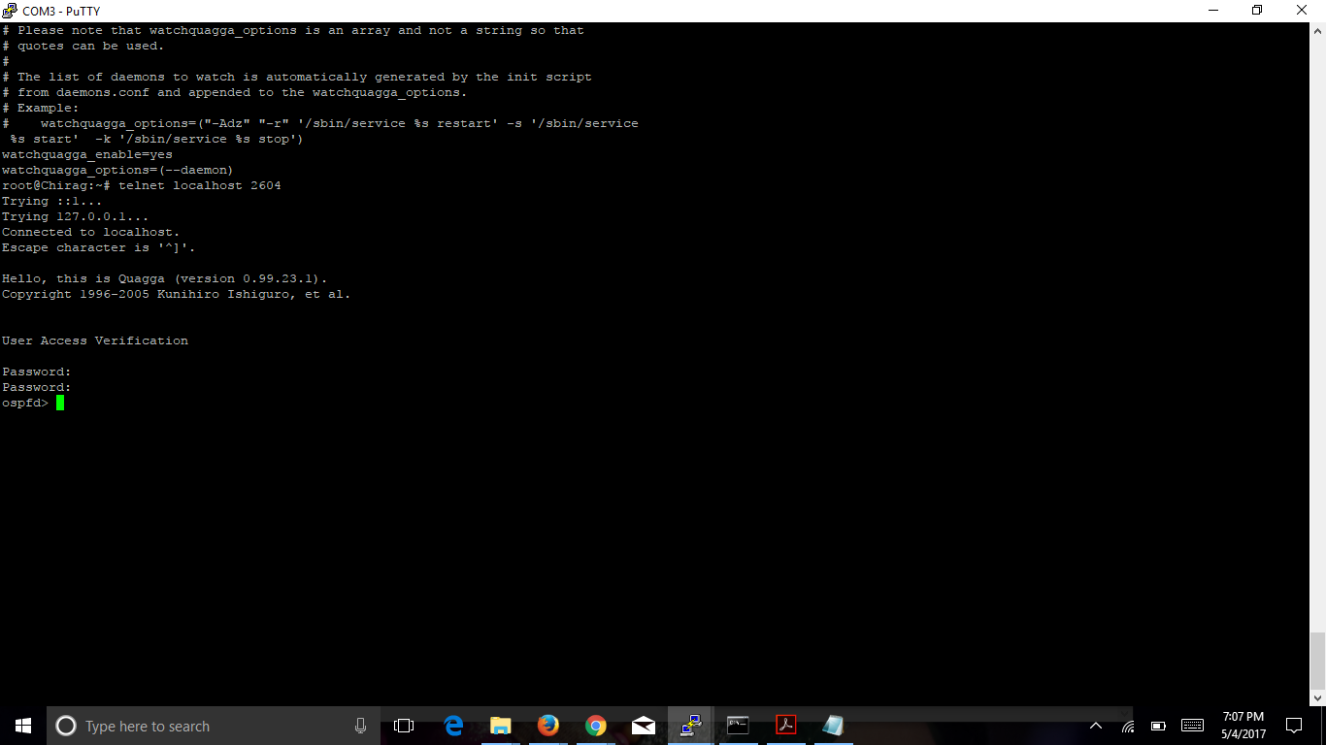

**Telnet localhost 2601(Zebra):**

**Show ip route:**

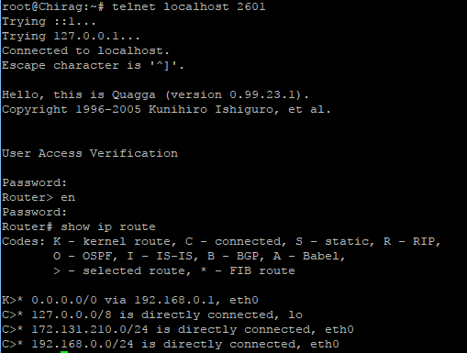

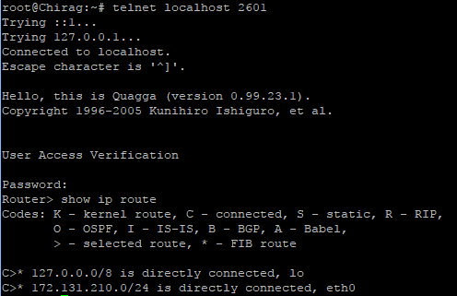

**Telnet localhost 2604(ospf):**

**Show ip ospf:**

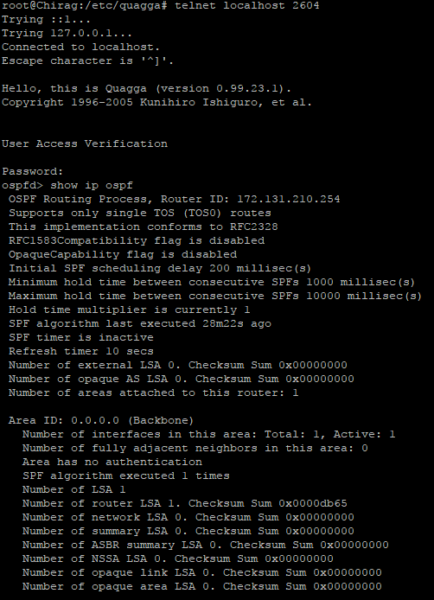

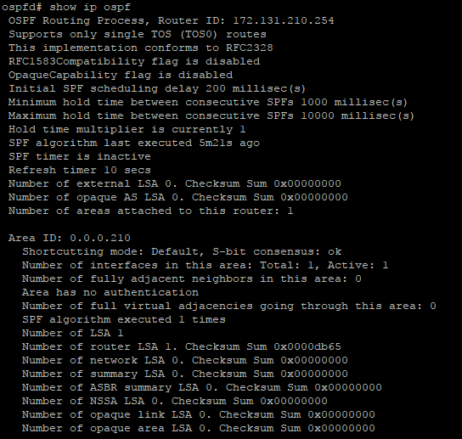

**ZEBRA.CONF:**

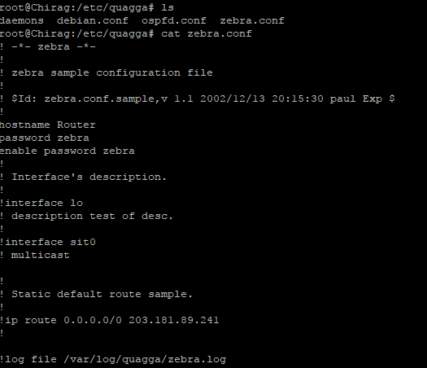

**OSPFD.CONF:**

